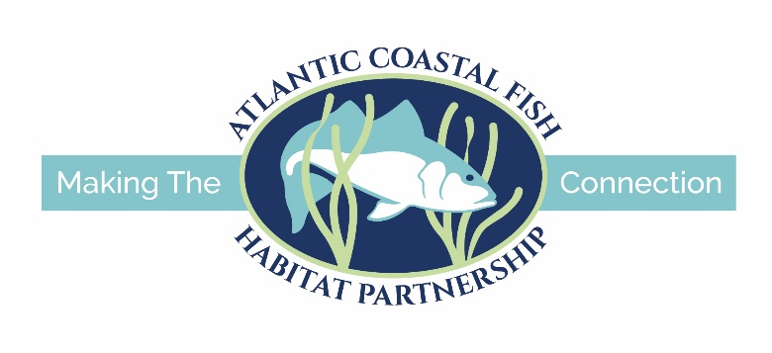
GENERAL ATLANTIC COASTAL FISH HABITAT PARTNERSHIP HABITAT CONSERVATION PROJECT APPLICATION FORM
Cover Page:
- Project Title
- Project Location (City, State)
- ACFHP Subregion (subregions found here)
- Applicant Information
  - Name of Organization
  - Address of Organization
  - Phone
  - Email
- Project Contact
  - Lead Project Officer and Title
  - Alternate contacts (if appropriate)
  - Address (if different from above)
  - Phone (if different from above)
  - Email (if different from above)
- Funding Information
  - Funding being sought for: __Design, __Planning, __ Construction, __Monitoring, __Outreach, __Land acquisition
  - Funding amount requested
  - Total cost of the project
  - Total amount secured
  - Total non-federal match
  - Total non-federal leverage
  - Total federal leverage

- Project Description:
- Project description (max words: 100)
- Provide one map of the project area
- Provide the GPS coordinates in decimal degrees for the project using UTM NAD 83
- Provide digital pictures of the project area (2 - 5)
- Project footprint (if applicable) and affected area (river miles for passage projects, acres for all other projects)
- For fish passage projects, provide the number of barriers between this project and the estuary.

- Scope of Work
A. Problem and specific cause of the problem (max words: 100)
B. Describe the objective of the project with reference to the problem (max words: 100)
C. Proposed methods (max words: 500)
D. Technical Design
E. Permits
F. Pre- and post-project monitoring
G. Outreach

- Evaluation Questions:
- Which ACFHP Subregional Priority Habitat(s) does the project address?
- Which of the ACFHP Habitat Conservation Objectives does the project address?
- How will the project address a root cause and contribute to a long-term, self-sustaining solution to the problem(s) described in the Scope of Work (Section III.A.)?
- Does this project mitigate the impacts of climate change? If so, how?
- Using the ACFHP Fish Habitat Conservation Area Mapping and Prioritization Tool, is the catchment (diadromous project) or hexagon (estuarine project) in which your project is located considered a “Restoration Opportunity Area” (scoring 20-60 points)? If not, please describe how this project will improve the score or why this catchment/hexagon is in need of restoration, based on the specific variables for which it did or did not receive points.
- Using the Species-Habitat Matrix Tool, which life stages and fish species ranked high or very high in the habitat you are restoring, and will benefit from this project?
(the following table is an example, please add/change line items as needed):

Habitat Type | Species | Life Stage | Rank
Coastal Headwater Pond | Alewife | Egg & Larva | Very High
Coastal Headwater Pond | Alewife | Juvenile & YOY | Very High
Moderate Gradient Tributary | Alewife | Juvenile & YOY | Very High
Moderate Gradient Tributary | Alewife | Spawning Adult | Very High

- Which species will directly benefit from this project?
- How does your project address DEIJ (diversity, equity, inclusion, and justice) issues in the community?

- Qualifications (not to exceed 1 page total):

- Budget Table and Budget Narrative
Please add or change lines as needed.

Partner name | Type* | Activity of Partner** | Budget Category*** | ACFHP Request | Non-federal leverage |  | Federal leverage |  | Total Contribution
 |  |  |  |  | In-kind | Cash | In-kind | Cash
Total Contribution

*Type – federal agency, state agency, local government, conservation group (local), conservation group (national), Native American tribe, private landowner, corporation/business, foundation, other
**Activity – engineering and design, planning and coordination, construction, monitoring, outreach and education, land acquisition, habitat assessment, research
***Budget categories – administration/technical services, construction material, construction labor, equipment, contractual, travel, supplies, other (describe)

Budget Narrative:

- Partners
Fill out the table below, adding rows as needed.
Partner name | Involvement

- Timeline of Project Activities
The following table is an example, please add/change line items as needed:
Project Activity | Anticipated Dates of Implementation
Project design | January 15-March 30, 20xx
Permitting process | February 25-June 1, 20xx
Pre-project monitoring | 5 events, March 15-May15, 20xx
Construction | July 1-July 15, 20xx
ACFHP/Service Annual Report | January 15, 20xx
Post-project monitoring | 1 year, beginning January 20xx

