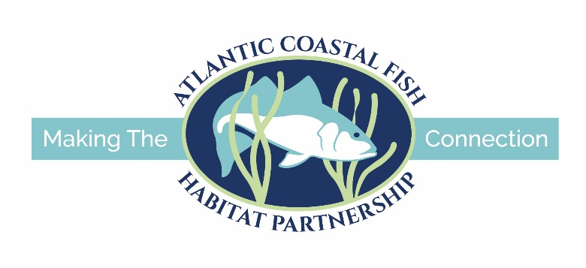
Atlantic Coastal Fish Habitat Partnership Funding
Through the National Fish Habitat Partnership Program
FY2024 PROJECT APPLICATION FORM
Please see application instructions located on the Atlantic Coastal Fish Habitat Partnership (ACFHP) website at: FY2024 Atlantic Coastal Fish Habitat Partnership Funding Cycle – Atlantic Coastal Fish Habitat Partnership (atlanticfishhabitat.org) to ensure that you correctly complete the application form.
Cover Page:
- Project Title
- Project Location (State, County, City, Congressional District)
- ACFHP Subregion
- Applicant Information
  - Name of Organization
  - Executive Director
  - Address of Organization
  - Phone
  - Fax
  - Email
  - Congressional district of applicant
  - DUNS Number and TIN
- Project Contact
  - Lead Project Officer and Title (if different from above)
  - Alternate contacts (if appropriate)
  - Address (if different from above)
  - Phone (if different from above)
  - Fax (if different from above)
  - Email (if different from above)
- Have you been working with a U.S. Fish and Wildlife Service contact on this project? If yes, please provide the following, if available:
  - Date coordination began and Service involvement
__ process grant/coop agreement __ assist with permit applications
__ assist with project design __ provide heavy equipment operators
__ provide engineer plans __ pre- and post- project monitoring
  - FIS Database Activity Number (obtained from Service contact)
  - Service Sponsoring Office
  - Name of Service contact
  - Letter or email of support from Service contact
- Funding Information
  - Funding being sought for: __Design, __Planning, __ Construction, __Monitoring, __Outreach, __Land acquisition
  - Funding amount requested
  - Total cost of the project
  - Total amount secured
  - Total non-federal match
  - Total non-federal leverage
  - Total federal leverage

- Project Eligibility (please answer ‘yes’ or ‘no’ to the following):
- Are the actions proposed mandated by a regulatory program, court order, or decree?
- Will any amount of the requested funds be applied to previous expenditures?
- Will the requested funds be used for realty costs associated with the project?
- Will the requested funds be used for operation or maintenance of facilities?
- Is the project primarily a research study?
- Will the requested funds be used for incentive payments (Annual payments to encourage participation (e.g. some NRCS Farm Bill programs))?

- Project Description:
- Project description (max words: 100)
- Provide one map of the project area
- Provide the GPS coordinates in decimal degrees for the project using UTM NAD 83
- Provide digital pictures of the project area (2 - 5)
- Project footprint (if applicable) and affected area (river miles for passage projects, acres for all other projects)
- For fish passage projects, provide the number of barriers between this project and the ocean.

- Scope of Work
A. Problem and specific cause of the problem (max words: 100)
B. Describe the objective of the project with reference to the problem (max words: 100)
C. Proposed methods (max words: 500)
D. Technical Design
E. Permits
F. Pre- and post-project monitoring
G. Outreach

- Evaluation Questions:
- Which ACFHP Subregional Priority Habitat(s) does the project address?
- Which of the ACFHP Habitat Conservation Objectives does the project address?
- Which of the NFHP Conservation Priorities does the project address?
- Is the project located in a priority area identified in an approved state or federal management plan?
- How will the project address a root cause and contribute to a long-term, self-sustaining solution to the problem(s) described in the Scope of Work (Section III.A.)?
- Does this project mitigate the impacts of climate change? If so, how?
- Using the ACFHP Fish Habitat Conservation Area Mapping and Prioritization Tool, is the catchment (diadromous project) or hexagon (estuarine project) in which your project is located considered a “Restoration Opportunity Area” (scoring 20-60 points)? If not, please describe how this project will improve the score or why this catchment/hexagon is in need of restoration, based on the specific variables for which it did or did not receive points.
- Using the Species-Habitat Matrix Tool, which life stages and fish species ranked high or very high in the habitat you are restoring, and will benefit from this project?
(the following table is an example, please add/change line items as needed):

Habitat Type | Species | Life Stage | Rank
Coastal Headwater Pond | Alewife | Egg & Larva | Very High
Coastal Headwater Pond | Alewife | Juvenile & YOY | Very High
Moderate Gradient Tributary | Alewife | Juvenile & YOY | Very High
Moderate Gradient Tributary | Alewife | Spawning Adult | Very High

- Which species will directly benefit from this project?
- How does your project address DEIJ (diversity, equity, inclusion, and justice) issues in the community?

- Qualifications (not to exceed 1 page total):

- Budget Table and Budget Narrative
Please add or change lines as needed. BOLD the non-federal contributions that count as match.

Partner name | Type* | Activity of Partner** | Budget Category*** | Pending/  received | ACFHP Request | Non-federal contribution |  | Federal Contribution |  | Total Contribution
 |  |  |  |  |  | In-kind | Cash | In-kind | Cash
Total Contribution

Budget Narrative:

- Partners
Fill out the table below, adding rows as needed.
Partner name | Involvement

- Timeline of Project Activities
The following table is an example, please add/change line items as needed:
Project Activity | Anticipated Dates of Implementation
Project design | January 15-March 30, 20xx
Permitting process | February 25-June 1, 20xx
Pre-project monitoring | 5 events, March 15-May15, 20xx
Construction | July 1-July 15, 20xx
ACFHP/Service Annual Report | January 15, 20xx
Post-project monitoring | 1 year, beginning January 20xx

- Alignment with the ACE Act

