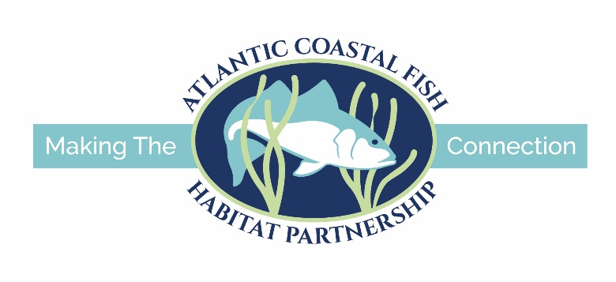

APPLICATION INSTRUCTIONS

for

FY2024 Atlantic Coastal Fish Habitat Partnership Funding

The Atlantic Coastal Fish Habitat Partnership (ACFHP) is requesting project applications for funding to restore and conserve habitat necessary to support coastal, estuarine dependent, and diadromous fish species. Federal funding available through the National Fish Habitat Partnership (NFHP) program will be used to support the top ranked proposals.

America’s Conservation Enhancement (ACE) Act was passed by Congress and signed by the President on October 30, 2020. The legislation made significant changes to project eligibility requirements for this funding opportunity; this is reflected in the requirements described below. The ACE Act places an emphasis on restoration efforts that will improve recreational fishing opportunities and public use of resources. Improvements in public access as a component of projects are also encouraged.

Specific requirements include:
• Requested NFHP grant funds must be matched 1:1 with non-federal funds. Non-federal match can include cash and/or in-kind labor, materials, or equipment, if there are no federal ties to those funds. State agency funds can be used for the non-federal match if labor and/or materials are not being matched to another federal grant and do not have a federal origin (e.g. WSFR). State agency funds that are used to match other federal grants would not be eligible as match.
• All NFHP funded projects must include an outreach/education component.
• Monitoring and evaluation measures must be included as part of the project application but should not make up a significant portion of the funding request.
• The ACE Act included special considerations for Indian Tribes. Please contact the ACFHP Chair for more details, if applicable.
• The ACE Act allows a state, local government, or other non-federal entity to receive NFHP funds for the acquisition of real property from willing sellers if the acquisition ensures public access for fish and wildlife-dependent recreation or contributes to a scientifically based, direct enhancement to the health of fish and fish populations as determined by the NFHP Board. All real property acquisition projects funded with NFHP funds must be approved by the state agency responsible for sovereign land ownership and management in the state in which the project is occurring. If you are applying for acquisition funding, contact the ACFHP Chair for more details.

These funds can only be used for land acquisition or on-the-ground habitat conservation and restoration projects and associated design and monitoring activities. They may not be used for projects required as part of a regulatory action. At this time, ACFHP is not soliciting applications for research projects that do not include on-the-ground habitat restoration. Construction phase projects are expected to have received all necessary permits and meet all environmental compliance requirements. All projects are expected to be completed within 18 months of receipt of funding.

Available funding: In past funding cycles, we typically supported 2-4 projects for a total of $90,000 – 250,000 annually. We do not have a maximum request amount. This is a very competitive process and the amount of funding applied for has always exceeded the amount available. As noted above, successful proposals must demonstrate a minimum 1:1 non-federal match. Once the requested NFHP grant funds are matched with non-federal funds/in-kind, an unlimited amount of federal and non-federal contributions to the project are allowed. ACFHP gives special consideration to projects with more than the minimum match.

Timeline: Applicants will be notified of their projects’ funding status as that information becomes available. Funding decisions will not be made until a federal budget is passed for FY2024. FY2024 starts on October 1, 2023. Applicants should not expect to hear anything until at least the last quarter of 2023. The total amount available to fund projects is unknown at this time.

Note regarding federal funds: NFHP funds are federal funds, administered through the U.S. Fish and Wildlife Service (USFWS). All organizations that receive NFHP funding are required to complete all requirements for federal grants, including registration on the federal System for Award Management (SAM.org), Automated Standard Application for Payments (ASAP), Grants Solutions grant management system, and provide interim and annual reports to the USFWS and ACFHP. NFHP funds are processed through a grant agreement completed through the USFWS Regional Offices or local Fish and Wildlife Conservation Office (FWCO). Grants are paid on a reimbursable basis and cannot cover pre-award costs. Recipients and sub-recipients of federal grants must comply with the requirements of the National Environmental Policy Act (NEPA), Section 7 of the Endangered Species Act (ESA), and Section 106 of the National Historic Preservation Act (NHPA). Environmental compliance documents must be provided to USFWS before any potentially impactful work related to the award can begin. If environmental compliance documents are not provided prior to the execution of the grant agreement, the award will be issued conditionally. In that case, the Recipient must not begin any potentially impactful work before the USFWS has notified them in writing that such work can begin. More detailed information from the USFWS about federal grant processes is available here.

Applications will be reviewed and ranked by ACFHP based on their potential to help the partnership meet its conservation objectives described in its Conservation Strategic Plan. For fish passage projects, you must submit separate proposals for each barrier (e.g., if you are removing a dam and fixing a culvert in the same river, you must submit two separate proposals).

The following is required to apply:
- Application Form: A blank application in Word format is available on the ACFHP website at: FY2024 Atlantic Coastal Fish Habitat Partnership Funding Cycle – Atlantic Coastal Fish Habitat Partnership (atlanticfishhabitat.org). The following pages of this document provide guidance for completing the application.

- Photographs and Photograph Release Form: Release forms are available on the ACFHP website at: FY2024 Atlantic Coastal Fish Habitat Partnership Funding Cycle – Atlantic Coastal Fish Habitat Partnership (atlanticfishhabitat.org). Forms should be signed, scanned, and emailed with your application.

The following is recommended but not required:

- Copies of any permit letters received to date from authorizing agencies.

- Letter of Support – Obtain a letter of support from the appropriate state natural resource agency or other pertinent supporters of your project. This letter can be from an ACFHP state contact. Contact information for ACFHP members can be found at: https://www.atlanticfishhabitat.org/our-team/.

Applications must be received by 5:00 pm Eastern time on Friday, January 20th, 2023. Applications in electronic format (MS Word format only) should be emailed to the ACFHP Chair, Kent Smith at kent.smith@myfwc.com.

Incomplete applications or those not in MS Word format will not be considered.

By submitting an application, you agree to use the ACFHP logo on your project outreach materials, share project reports, monitoring results, and before and after photos with ACFHP, as well as agree to ACFHP featuring your project on its website. To learn about our funded projects, sign up for our newsletter.

For questions, please contact:

Kent Smith, ACFHP Chair
Phone: (850) 617-9504
Email: kent.smith@myfwc.com

And

Jessica Coakley, ACFHP Vice Chair
Phone: 302-526-5252
Email: jcoakley@mafmc.org

APPLICATION GUIDANCE
This section is provided to assist applicants in preparing a complete application. It provides instructions and guidance for each of the items on the application form. A blank application form can be found on the ACFHP website.

Cover Page:
The cover page should contain the required information in the sequence and format specified below and in the following page. Do not attach an executive summary or any additional documentation that is not requested.
- Project Title
The title must be 100 characters or less and contain the initials NFHP as well as the type of project, body of water, city, and state (ex. SAV Restoration, Peconic Estuary, Suffolk County, NY NFHP).
- Project Location (State, County, City, Congressional District)
To find congressional districts, please visit: https://www.census.gov/mycd/
- ACFHP Subregion
Please refer to the map of ACFHP Subregions in Appendix A.
- Applicant Information
  - Name of Organization
This organization will be named as the grantee.
  - Executive Director
Alternatively, the person that should receive all contractual information for signature.
  - Address of Organization
  - Phone
  - Fax
  - Email
  - Congressional district of applicant
Please use web address above to find district.
  - DUNS Number and TIN
- Project Contact
  - Lead Project Officer and Title (if different from above)
  - Alternate contacts (if appropriate)
  - Address (if different from above)
  - Phone (if different from above)
  - Fax (if different from above)
  - Email (if different from above)
- Have you been working with a U.S. Fish and Wildlife Service contact on this project? If yes, please provide the following, if available:
  - Date coordination began and Service involvement
Please check the box below to indicate the level of Service involvement in your project
__ process grant/coop. agreement __ assist with permit applications
__ assist with project design __ provide heavy equipment operators
__ provide engineer plans __ pre- and post- project monitoring

  - FIS Database Activity Number (obtained from Service contact)
  - Service Sponsoring Office
  - Name of Service contact
  - Letter or email of support from Service contact
- Funding Information
  - Funding being sought for: __Design, __Planning, __ Construction, __Monitoring, __Outreach, __Land acquisition
  - Funding amount requested
Funding amount requested from ACFHP, through this application.
  - Total cost of the project
  - Total amount secured
The amount of funding (cash and in-kind) that has been committed to date.
  - Total non-federal match
Total amount of non-federal dollars used as match for the ACFHP funds you are applying for. Non-federal match can include cash and/or in-kind labor, materials, or equipment if there are no federal ties to those funds. State agency funds can be used for the non-federal match if labor and/or materials are not being matched to another federal grant and do not have a federal origin (e.g. WSFR). Funds that are used to match other federal grants would not be eligible as match.
  - Total non-federal leverage
Non-federal contributions (both pending and secured) that are not being counted as match. For example, if you have donations, volunteer time, state funding, etc. for the project that are already counted as match elsewhere, include it here.
  - Total federal leverage
Total amount of federal contributions (pending and secured) for the project. Please include in-kind and cash match from all federal sources.

- Project Eligibility (please answer ‘yes’ or ‘no’ to the following):
If you answer ‘yes’ to any of these questions, the project is ineligible for funding.
- Are the actions proposed mandated by a regulatory program, court order, or decree?
- Will any amount of the requested funds be applied to previous expenditures?
- Will the requested funds be used for realty costs associated with the project?
- Will the requested funds be used for operation or maintenance of facilities?
- Is the project primarily a research study?
- Will the requested funds be used for incentive payments (Annual payments to encourage participation (e.g. some NRCS Farm Bill programs))?

- Project Description:
Please adhere to the word limits. This information will be entered into a database that cannot accept more words than the number listed.
- Project description (max words: 100)
Provide a short summary that conveys an understanding of what the project involves and will accomplish. Please briefly describe the following: location, need for the project, purpose, goals, objectives, phase of the project to be completed, who will do the work, and who owns the land.

- Provide one map of the project area
The map should be in the following format:
- Color (preferred) or black and white (acceptable)
- Large-scale detail (e.g., 1 inch = 1 mile, or greater), clearly showing the scope and location of the project
- Should include scale bar, north arrow, counties or other appropriate political boundaries, etc.
- Provide the GPS coordinates in decimal degrees for the project using UTM NAD 83
If the project involves a passage barrier, please include the coordinates and name for the barrier. If it is a habitat project, please include coordinates of a representative location within the center of the project boundary. If the project includes multiple sites, please include coordinates for each site.
- Provide digital pictures of the project area (2 - 5)
Each photo should be in JPG format (sent separately from the application for higher resolution) and be accompanied by:
- A short, descriptive caption
- Photographer’s name and organization
- Signed photograph release form
- Project footprint (if applicable) and affected area (river miles for passage projects, acres for all other projects)
For example, if you are restoring an oyster reef, the footprint would be the acreage of the oyster reef and the affected area would be, for example, the acreage of the marsh it protects. If removing a fish passage barrier, you would not have to include the footprint, and the affected area would be the number of river miles restored.
- For fish passage projects, provide the number of barriers between this project and the ocean.
If the barrier you are working on is the first blockage from the ocean, your answer would be ‘0,’ if there are two barriers between your project and the ocean, your answer would be ‘2.’

- Scope of Work
A. Problem and specific cause of the problem (max words: 100)
Describe the current threat to the habitat resource.
B. Describe the objective of the project with reference to the problem (max words: 100)
C. Proposed methods (max words: 500)
Provide a summary of the specific on-the-ground activities to be undertaken to achieve the project objectives and specifically address which portion of the project will be paid for by requested ACFHP funds.
D. Technical Design
Briefly describe the technical design and scientific justification for why this design will achieve the objectives listed above. Describe the current stage of project design, who completed or will complete the project design, and how the design will be implemented. If available, provide an electronic copy of the project design (attachment should not exceed 3 pages).
E. Permits
For projects that require permits and consultations, applicant should list all necessary permits, the timeline for completing permits, the status of the permits, and include documentation of permits already secured for the project.

F. Pre- and post-project monitoring
Describe all pre- and post- project monitoring and evaluation activities, including quantifiable success criteria (e.g., acres restored, stream miles opened, number of fish passing blockage, documented spawning of target species) used to determine if the proposed objectives were achieved. Monitoring required by permits should be included in this description. Describe how the monitoring plan will achieve scientifically sound results with respect to sampling design and statistical analysis.
G. Outreach
Describe outreach to the local or regional community that will be conducted related to this project. Examples include communication with congressional offices, such as press releases, ribbon cutting ceremonies, and town halls; school field trips; on-site signage; and communication about the project to the natural resource and scientific community.

- Evaluation Questions:
If there is more than one project site and sites are located in more than one region (non-fish passage projects), answer only for the region in which the majority of the project sites reside.
- Which ACFHP Subregional Priority Habitat(s) does the project address?
Definitions can be found in Appendix B.

North Atlantic

Riverine Bottom
Submerged Aquatic Vegetation
Marine and Estuarine Shellfish Beds

Mid-Atlantic

Riverine Bottom
Submerged Aquatic Vegetation

Marine and Estuarine Shellfish Beds
Tidal Vegetation

South Atlantic

Riverine Bottom
Submerged Aquatic Vegetation

Marine and Estuarine Shellfish Beds
Tidal Vegetation

South Florida
Submerged Aquatic Vegetation

Coral and Live/Hard bottom
Tidal Vegetation (mangrove)
- Which of the ACFHP Habitat Conservation Objectives does the project address?
Please specify the Habitat Conservation Objective(s) addressed by the project, which can be found in Appendix C.
- Which of the NFHP Conservation Priorities does the project address?
NFHP Conservation Priorities can be found in Appendix D.
- Is the project located in a priority area identified in an approved state or federal management plan?
For example, a State Wildlife Action Plan, state or federal recovery plan, or National Estuary Program Comprehensive Conservation and Management Plan. Please provide a website address or copy of the most recent version of the plan.
- How will the project address a root cause and contribute to a long-term, self-sustaining solution to the problem(s) described in the Scope of Work (Section III.A.)?
If it is a living shoreline, you must demonstrate with citation of your state’s definition of a living shoreline how the project will benefit fish species.
In addition, please address how long the proposed project will last before maintenance is required.
- Does this project mitigate the impacts of climate change? If so, how?

- Using the ACFHP Fish Habitat Conservation Area Mapping and Prioritization Tool, is the catchment (diadromous project) or hexagon (estuarine project) in which your project is located considered a “Restoration Opportunity Area” (scoring 20-60 points)? If not, please describe how this project will improve the score or why this catchment/hexagon is in need of restoration, based on the specific variables for which it did or did not receive points.
To access the maps, user guide, how-to video, and final report, see the ‘Fish Habitat Conservation Area Mapping and Prioritization Project’ section of the ACFHP Science and Data Project webpage: https://www.atlanticfishhabitat.org/science-and-data-projects/.

- Using the Species-Habitat Matrix Tool, which life stages and fish species ranked high or very high in the habitat you are restoring, and will benefit from this project?
The table below is an example, please add/change line items as needed.
To generate a list, in the Species-Habitat Matrix Tool (https://www.atlanticfishhabitat.org/species-habitat-matrix/), enter your Subregion (see Appendix A for subregional boundaries), Habitat Category that the project will benefit (see Appendix B for Habitat Categories and Habitat Types), and ‘high’ and ‘very high’ under ‘Rank.’ Fill in the ‘Habitat Type,’ ‘Species,’ ‘Life Stage,’ and ‘Rank’ in the table on the following page, adding rows as necessary.

Species | Habitat Type | Life Stage | Rank
Alewife | Coastal Headwater Pond | Egg & Larva | Very High
Alewife | Coastal Headwater Pond | Juvenile & YOY | Very High
Alewife | Moderate Gradient Tributary | Juvenile & YOY | Very High
Alewife | Moderate Gradient Tributary | Spawning Adult | Very High

- Which species will directly benefit from this project?
List the species, including USFWS priority species and/or trust resources that will directly benefit from the goals of the project. Be sure to state that species’ status (at-risk, threatened, endangered, state species of concern, etc.).
J. How does your project address DEIJ (diversity, equity, inclusion, and justice) issues in the community?
Consider your organization, partners, and stakeholders.

- Qualifications (not to exceed 1 page total):
Include a brief abstract of relevant qualifications for the project lead and most important team members.

- Budget Table and Budget Narrative
Please add or change lines as needed. BOLD the non-federal contributions that count as match. Overhead such as utilities, office space, and salary to prepare applications and develop partnerships will not be funded with ACFHP funds and should not be a line item or built into the project. Project coordination salary, activities that directly relate to completion of the project, such as travel and salary to do design work, get and/or monitor contracts, are allowable expenses with ACFHP funds but should not constitute more than 10% of the funding request.

Partner name | Type* | Activity of Partner** | Budget Category*** | Pending/  received | ACFHP Request | Non-federal contribution |  | Federal Contribution |  | Total Contribution
 |  |  |  |  |  | In-kind | Cash | In-kind | Cash
Total Contribution

*Type – federal agency, state agency, local government, conservation group (local), conservation group (national), Native American tribe, private landowner, corporation/business, foundation, other
**Activity – engineering and design, planning and coordination, construction, monitoring, outreach and education, land acquisition, habitat assessment, research
***Budget categories – administration/technical services, construction material, construction labor, equipment, contractual, travel, supplies, other (describe)

Budget Narrative
Provide a description of each of the budget items for which ACFHP funding is requested above.
Ex.
- Heavy Equipment Rental and Operation – Rental of backhoe and dump truck = $1,500 per day for 2 days = $3000. Two heavy Equipment operators at $100 per hour per person = $200 an hour for 10 hours = $2000. Total for this line item: $5000
- Contractual Labor – One crew lead at an hourly rate of $40/hour will spend 5 weeks (200 hours) planting and 25 hour on planning (total of 225 hours) for a total of $9000. Two technicians at an hourly rate of $20/hour each will be planting for 5 weeks (200 hours) for a total of $8000. Total for this line item: $17,000
- Pre- and Post-project physical monitoring – One 8-hour day of surveys will be conducted each year. One biologist at $35/hour, 4 technicians at $15/hour each and $40 per day for gas for a cost of $800/day. Equipment costs for boots and waders is $200 for a total cost per year of $1000. Surveys will be conducted for 5 years to assess the project area. Total for this line item: $5000

- Partners
Fill out the table below, adding rows as needed.
Partner name | Involvement*

*Involvement – funder, landowner, permitting, project evaluation, project implementation, project lead, technical assistance (can be more than one)

- Timeline of Project Activities
The following table is an example, please add/change line items as needed.
Provide a summarized list of all project activities, not only activities for which ACFHP funds are being requested, using the format below.
Project Activity | Anticipated Dates of Implementation
Project design | January 15-March 30, 20xx
Permitting process | February 25-June 1, 20xx
Pre-project monitoring | 5 events, March 15-May15, 20xx
Construction | July 1-July 15, 20xx
ACFHP/NFHP Annual Report | January 15, 20xx
Post-project monitoring | 1 year, beginning January 20xx

- Alignment with the ACE Act
If not addressed in a previous response, please describe the extent that the project addresses the following items in a concise format:
• Fulfills a local or regional priority that is directly linked to the ACFHP Conservation Strategic Plan
• Addresses the national conservation priorities of the NFHP Board (Appendix D)
• Is supported by the findings of ACFHP’s Conservation Maps (found in Section IV G) or the NFHP Board’s ‘Through a Fish’s Eye' and aligns with or is compatible with other conservation plans
• Identifies appropriate monitoring and evaluation measures and criteria
• Provides well defined budget linked to deliverables and outcomes
• Addresses the causes and process behind the decline of fish populations or fish habitats
• Includes a local or regional outreach or educational component
• Will increase fish populations in a manner that leads to recreational fishing opportunities for the public
• Increases public access to land or water for fish and wildlife dependent recreation
• Advances the conservation of Species of Greatest Conservation Need (SGCN) as designated by State agencies
• Advances the conservation of fish and fish habitat under Magnuson-Stevens Fishery Conservation and Management Act: governing law for marine federal fisheries management
• Promotes healthy fish habitats so that desired biological communities are able to persist and adapt

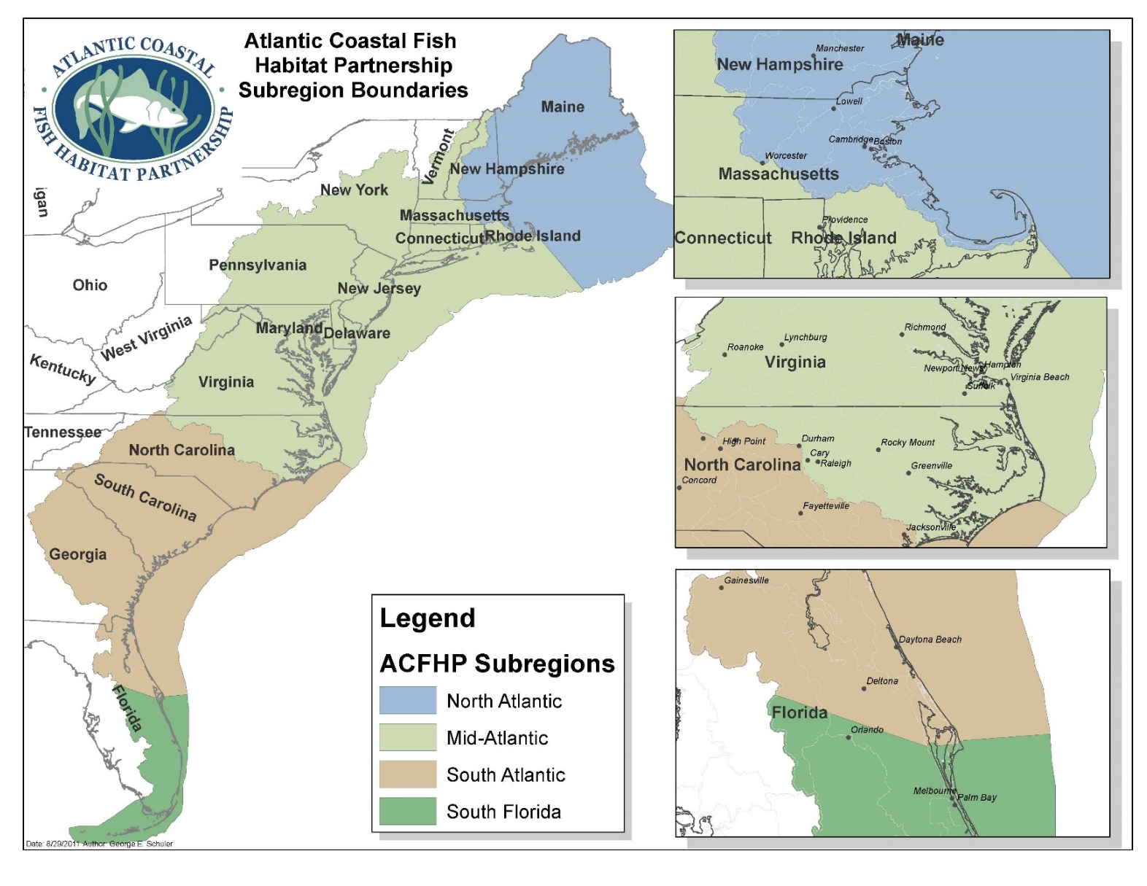
Appendix A. Atlantic Coastal Fish Habitat Partnership Subregional Boundaries: North Atlantic, Mid-Atlantic, South Atlantic, and South Florida

Appendix B: ACFHP Habitat Characterizations

Note that the habitat category into which a habitat type falls is underlined.

Marine and Estuarine Shellfish Beds

Oyster aggregations/reef
Structures formed by the Eastern oyster (Crassostrea virginica) that provide the dominant structural component of the benthos, and whose accumulated mass provides significant vertical relief (> 0.5 m).

Scallop beds
Areas of dense aggregations of scallops on the ocean floor. Common Atlantic coast species include: (1) the large Atlantic sea scallop (Placopecten magellanicus), which ranges from Newfoundland to North Carolina; (2) the medium-sized Atlantic calico scallop (Argopecten gibbus), which is found in waters south of Delaware; and (3) the bay scallop (Argopecten irradians), which occurs from Cape Cod to Florida, as well as in the Gulf of Mexico.

Hard clam beds
Dense aggregations of the hard clam (Mercenaria mercenaria) found in the subtidal regions of bays and estuaries to approximately 15 m in depth. Clams are generally found in mud flats and firm bottom areas consisting of sand or shell fragments.

Shell accumulations
Shells of dead mollusks sometimes accumulate in sufficient quantities to provide important habitat. Accumulations of Eastern oyster shells are a common feature in the intertidal zone of many southern estuaries.

Coral and Live/Hard Bottom

Coral reefs
Reef-building corals are of the order Scleractinia, in the class Anthozoa, of the phylum Cnidaria. Coral accumulations are restricted to warmer water regions, where the average monthly temperature exceeds 18°C (64°F) throughout the year. Through symbiosis with unicellular algae, reef-building corals are the source of primary production in reef communities.

Patch reef, soft corals, or anemones
A patch reef is an isolated, often circular, coral reef usually found within a lagoon or embayment. Soft corals are species of the anthozoan order Alcyonacea, of the subclass Octocorallia. In contrast to the hard or stony corals, most soft corals do not possess a massive external skeleton (e.g. sea pens and sea fans). Anemones are cnidarians of the class Anthozoa, that possesses a flexible cylindrical body and a central mouth surrounded by tentacles found in soft sediments.

Live rock
Calcareous rock that is removed from the vicinity of a coral reef with some of the life forms still living on it. These may include bacteria, coralline algae, sponges, worms, crustaceans, and other invertebrates.

Macroalgae
Large marine multi-cellular macroscopic algae (seaweeds). There are three types of macroalgae: green, brown, and red. Examples of macroalgae species found along the Atlantic coast include:

Chlorophyta (green algae)

Ulva lactuca, sea lettuce

Phaeophyta (brown algae)
Fucus vesiculosus, bladderwrack; Laminaria spp.; Sargassum spp.

Rhodophyta (red algae)

Chondrus crispus, Irish moss

Submerged Aquatic Vegetation (SAV)
SAV refers to rooted, vascular plants that live below the water surface in large meadows or small patches in coastal and estuarine waters. SAV can be further classified by the range of salinity of the waters in which they are found.

Tidal fresh and oligohaline plant species
Generally found in areas where salinity ranges from 0.5 to 5.0. Examples include:
Vallisneria americana, wild celery
Ceratophyllum demersum, coontail

Mesohaline and polyhaline plant species
Generally found in areas where salinity ranges from 5.0 up to 30. Examples include:
Zostera marina, eelgrass
Ruppia maritima, widgeon grass

Tidal Vegetation

Estuarine emergent marsh
Salt marsh is an environment in the coastal intertidal zone between land and brackish water. The low marsh zone floods twice daily, while the high marsh floods only during storms and unusually high tides. Smooth cordgrass (Spartina alterniflora) dominates the regularly flooded low marsh along much of the Atlantic coast. In addition, salt meadow cordgrass (S. patens), saltgrass (Distichlis spicata), and needle rush (Juncus spp.) species comprise much of the vegetative community of the mid to upper saltmarsh and brackish marsh.

Tidal freshwater marsh
Tidal freshwater marsh occurs where the average annual salinity is below 0.5. It is found along free-flowing coastal rivers, and is influenced twice daily by the incoming tides. Tidal freshwater marsh can be located just upstream of the salt front, where the river essentially backs up as it meets resistance from high tides. Tidal freshwater marsh is characterized by salt intolerant plant species. These include: giant cordgrass (S. cynosuroides), sawgrass (Cladium jamaicense), cattails (Typha spp.), arrow arum (Peltandra virginica), pickerelweed (Pontedaria cordata), blue flag (Iris virginica), and softstem bulrush (Scirpus validus).

Mangrove
The mangrove ecological community includes four tree species collectively called mangroves. This swamp system occurs along intertidal and supratidal shorelines in southern Florida. The four species found in Florida mangrove swamps are:
Rhizophora mangle, red mangrove
Avicennia germinans, black mangrove
Laguncularia racemosa, white mangrove
Conocarpus erectus, buttonwood

Unvegetated Coastal Bottom

Loose fine bottom
Submerged underwater bottom habitat in estuaries and oceans where the dominate sediment type is mud, silt, or sand.

Loose coarse bottom
Submerged underwater bottom habitat in estuaries and oceans where the dominant sediment type ranges from gravel to cobble.

Firm hard bottom
Submerged underwater bottom habitat in estuaries and oceans where embedded rock or boulders are the dominate sediment types.

Structured sand habitat
Linear, narrow sand features that develop where a stream or ocean current promotes deposition of sand.

Riverine Bottom

Higher gradient headwater tributaries
Streams in which the dominant substrate is comprised of gravel and cobble. The stream slope is greater than 2%. This characterization includes 1st to 3rd order streams.
Moderate gradient tributaries
Streams in which the dominant substrate is comprised of sand, gravel, and small cobble. The stream slope is between 0.51% and 2.0%. This characterization includes 1st to 3rd order streams.
Moderate gradient large mainstem river coarser substrate
Rivers in which the dominant substrate is sand, gravel, and cobble. The stream slope is between 0.51% and 2%. This characterization includes 4th order rivers and above.
Moderate gradient large mainstem river finer substrate
Rivers in which the dominant substrate is fine sediments (silt, mud, sand). The stream slope is between 0.51% and 2%. This characterization includes 4th order rivers and above.

Low gradient coastal streams
Generally low gradient 0% to 0.05% in slope. This characterization includes 1st to 3rd order streams located along the coast.

Non-tidal freshwater mussel beds
Freshwater mussel beds, located above tidal influence.

Coastal headwater pond
A pond connected to coastal streams and rivers, generally located near the headwaters.

Non-tidal freshwater marsh
A marsh that occurs in the non-tidal section along a river. The main feature of a freshwater marsh is its openness, with only low-growing or “emergent” plants. It may include grasses, rushes, reeds, typhas, sedges, and other herbaceous plants (possibly with low-growing woody plants) in a context of shallow water.

Appendix C. ACFHP Habitat Conservation Objectives

Conservation Objective 1: Work with partners to protect, restore, or maintain resilient Subregional Priority Habitats (using strategies outside of fish passage) to optimize ecosystem functions and services to benefit fish and wildlife.

Conservation Objective 2: Work with partners to support the maintenance of water quality and hydrology standards for functional priority habitats and improvement of water quality in degraded priority habitat areas.

Conservation Objective 3: Coordinate with partners to restore, enhance, and maintain adequate and effective fish passage to ensure connectivity within and among required Subregional Priority Habitats.

Appendix D. NFHP Conservation Priorities
        - Conserve waters and habitats where all processes and functions are operating within their expected range or natural variation
        - Conserve hydrologic conditions for fish
        - Conserve physical and living habitats and features that support viable and sustainable species and/or populations in impacted or at-risk systems
        - Reconnect fragmented fish habitats
        - Conserve water quality for fish
        - Support the structure and function of FHPs
        - Enhance recreational, commercial, subsistence, and traditional fishing opportunities when conducting projects that conserve fish habitat

Strahler Stream Order is a hierarchical classification of streams. Headwaters are the first order, and two first order streams combine to form a second order stream. Two second order streams form a third order stream, and so on.

